Unit1: File Handling
- Which methods are used to read from a file? Explain any two with example
Ans: The methods used to read from a file in Python are:
- read()
- readline([n])
- readlines()

i.The read() method reads the entire content of a file and returns it as a string.
Example:
file= open("data.txt", "r")
print(file.read())
file.close()
If the file data.txt contains:
Hello, Paras Dangi!
Good Morning.
Output:
Hello, Paras Dangi!
Good Morning.

ii. The readline([n]) method reads a single line from the file.
If a number ‘n’ is specified, it reads up to ‘n’ characters from the line.
Example:
file1 = open("data.txt", "r")
print(file1.readline())
file1.close()
If the file data.txt contains:
Hello, Paras Dangi!
Good Morning.
Output:
Hello, Paras Dangi!

- Write a program to read an entire text file.
Ans: Code:
File.py:
file= open("data.txt", "r")
print(file.read())
file.close()
data.txt:
Hello, Paras Dangi!
Good Morning.
Output:
Hello, Paras Dangi!
Good Morning.

- Differentiate between:
  - text file and binary file.
Ans: 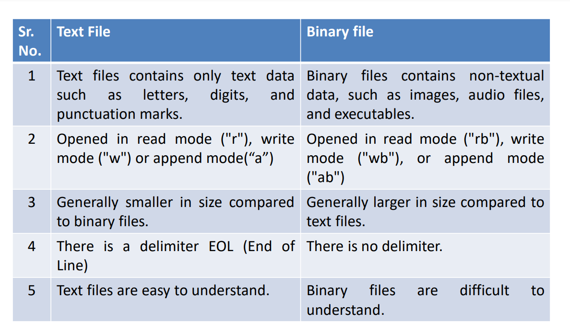

  - readline() and readlines()
Ans:
Feature | readline() | readlines()

Definition | Reads one line at a time from the file. | Reads all lines from the file and returns them as a list.

Return Type | Returns a string (single line). | Returns a list of strings (each line as an element).

Usage | Used when we want to read the file line by line. | Used when we need all lines at once.

Memory Usage | Efficient for large files (reads one line at a time). | Loads the entire file into memory, which can be inefficient for large files.

Newline (\n) | Retains the newline character (\n) at the end of each line. | Each list element includes a newline (\n).

  - write() and writelines()
Ans:
Feature | write() | writelines()

Definition | Writes a single string to a file. | Writes a list of strings to a file.

Input Type | Accepts a single string. | Accepts a list or tuple of strings.

Newline (\n) Handling | Does not add a newline (\n) automatically; you must add it manually. | Does not add a newline (\n) automatically; each string in the list must have \n if needed.

Usage | Used for writing a single line or word to a file. | Used for writing multiple lines at once.

- Write the use and syntax for the following methods:
  - open()
Ans: Use:
The open() method opens a file for reading, writing, or appending.
Syntax:
FileObject=open("filename", "mode")
  - read()
Ans: Use:
The read() method reads the entire content of a file and returns it as a string.
Syntax:
FileObject.read()
  - seek()
Ans: Use:
Moves the file cursor to a specific position.
Syntax:
FileObject.seek(offset, [from_what])
Where,
Offset:Required Parameter; Number of positions to move forward.
from_what:Optional Parameter;It defines point of reference to start from which place.(0/1/2)
0 → Start of file (default).
1 → Current position.
2 → End of file.

  - tell()
Ans: Use: Returns the current position of the file cursor.
Syntax:
file_object.tell()

- Write the file mode that will be used for opening the following files.
Also, write the Python statements to open the following files:
- text file “example.txt” in both read and write mode
Ans: File Mode: "r+"
Python Statement: file=open("example.txt", "r+")

- binary file “bfile.dat” in write mode
Ans: File Mode: "wb"
Python Statement: file = open("bfile.dat", "wb")

- text file “try.txt” in append and read mode
Ans: File Mode: "a+"
Python Statement: file = open("try.txt", "a+")

- binary file “btry.dat” in read only mode.
Ans: File Mode: "rb"
Python Statement: file = open("btry.dat", "rb")

- What is the difference between the following set of statements (a) and (b):
  - P = open(“practice.txt”,”r”)
P.read(10)
  - with open(“practice.txt”, “r”) as P:
x = P.read()
Ans:
Feature | (a) Using open() | (b) Using with open()

Syntax | P = open("practice.txt", "r") | with open("practice.txt", "r") as P:

File Handling | Manual file handling. Needs P.close() to release resources. | Automatically handles file closure after execution.

Reading Behavior | P.read(10) reads only the first 10 characters. | P.read() reads the entire file.

Memory Usage | Reads only a small part, useful for large files. | Reads the whole file, which may not be efficient for large files.

Error Handling | If an error occurs before calling close(), the file remains open, possibly causing resource leakage. | Even if an error occurs, Python automatically closes the file after exiting the with block.

- Write a command(s) to write the following lines to the text file named hello.txt. Assume that the file is opened in append mode.
  - “Welcome my class”
“It is a fun place”
“You will learn and play”
Ans:
file = open("hello.txt", "a")
file.write("Welcome my class\n")
file.write("It is a fun place\n")
file.write("You will learn and play\n")
file.close()

- Write a command(s) to perform following on hello.txt file:
  - To read data from 5th position in file.
Ans: with open("hello.txt", "r") as file:
file.seek(4)
data = file.read()
print("Data from 5th position:", data)

  - To insert data at a 10th specific Position in file.
Ans: with open("hello.txt", "r+") as file:
content = file.read()
file.seek(10)
new_content = content[:10] + "Hello Paras Dangi." + content[10:]
file.seek(0)
file.write(new_content)

  - To return current position of file pointer.
Ans: with open("hello.txt", "r") as file:
file.read()
position=file.tell()
print("Current file pointer position:", position)

- Write a Python program to open the file hello.txt used in question no 7 in read mode to display its contents. What will be the difference if the file was opened in write mode instead of append mode?
Ans:

- Write a Python Program to define following functions on “Demo.txt” file:
  - Write_in_file() : To write contents into file
  - Read_from_file(): To read contents from file
Unit2: Python Libraries
      - List the visualization libraries used in python.
      - List the Statistical Analysis libraries used in python.
      - List the Deep Learning libraries used in python.
      - What is NumPy? Or What is the purpose of NumPy in Python?

Write a NumPy code snippet to create an array of zeros.

Write a NumPy code snippet to create an array of ones.

How do I create a NumPy array.

What are the main features of Numpy

How do I access elements in a NumPy array?

How do you reshape a NumPy array?

Explain Numpy attributes.

What is the shape attribute in a NumPy array?

How can you create a NumPy array from a Python list?

How to perform element-wise operations on NumPy arrays?

Define the min and max function in NumPy.

How can you access elements in a NumPy array based on specific conditions?

What is the difference between slicing and indexing in NumPy?

How do you sort a NumPy array in ascending or descending order?

What is difference between NumPy and Pandas?

What are ways of creating 1D, 2D and 3D arrays in NumPy

How do you find the mean, median, and standard deviation of a NumPy array.

How do you initialize an empty array or an array of zeros/ones in NumPy?

How do you initialize an empty array or an array of zeros/ones in NumPy?

Explain the difference between one-dimensional, two-dimensional, and multi-dimensional arrays.

Compare NumPy, Pandas or SciPy.
Unit3: Exception Handling
- What is the use of pass statement?
- Write any two common exceptions in Python.
- Which are built in exceptions in Python?
- What is the use of finally block?
- List the syntax for handling exception.
- Explain various types of exceptional handling in Python.
- Explain Exception handling in python with example. (try-except-else) OR How to handle exception in Python?
- Write the syntax of the raise statement & explain it. (Syntax, purpose, explanation, example). OR How to raise an exception with arguments.
- Explain EXCEPT Clause with no exception.
- Write a note on Custom Exception. (What Custom exception, Syntax, example)
- Write a note on assert statement. (Syntax, purpose, explanation, example)
- Write a Python program to check for Zero Division Error Exception.
- Write a function that asserts the given number is positive.
- Write a function that raises this exception if a negative number is passed.
- Write a program to raise a user defined exception to check if age is less than 18.

Unit4: GUI Programming
- Write the uses of Tkinter
- Write the Steps to setup a Tkinter Application
- List names of Tkinter Widgets.
- Write a note on Geometry Management. Or Explain types of Geometry Management or
Explain following Geometry Management types:
- Grid
- Place
- Pack
- Explain Tkinter frame.
- Explain Tkinter Button.
- Explain Tkinter Label.
- Explain Tkinter Entry.

